ASSIGNMENT 6.1

**DATASET:**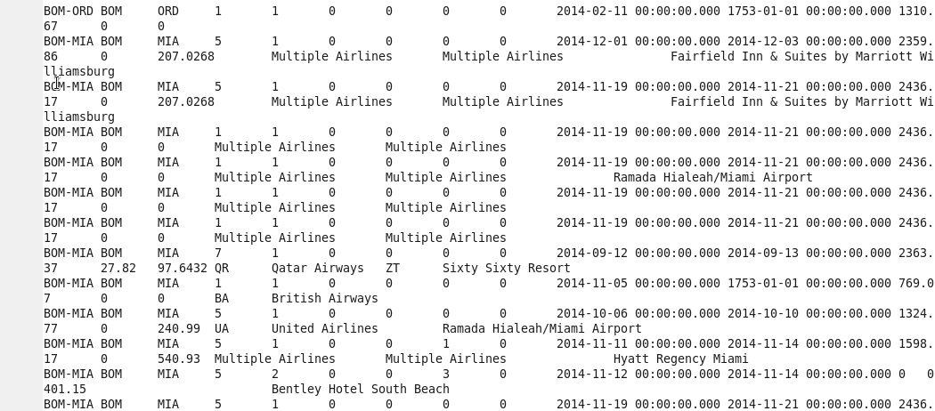

DRIVER:

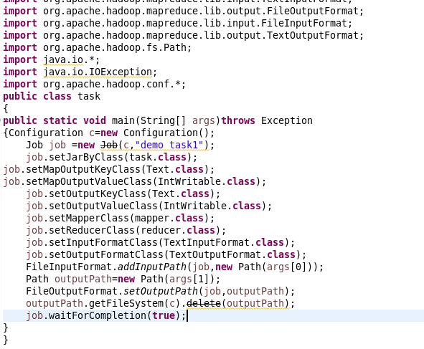

REDUCER:

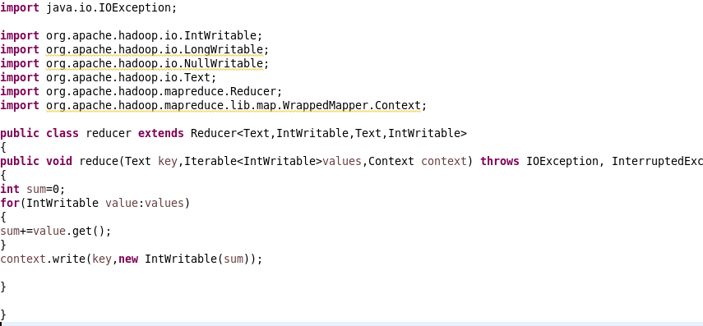

**1) Find out how many people has chosen their destination as MIA and MCO**

MAPPER:

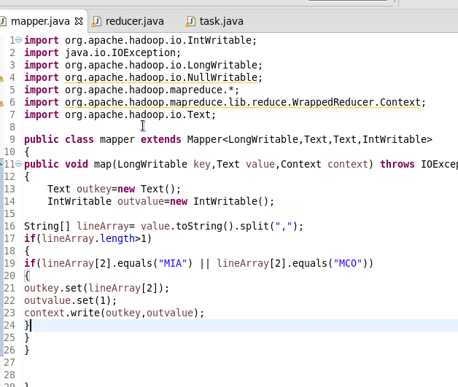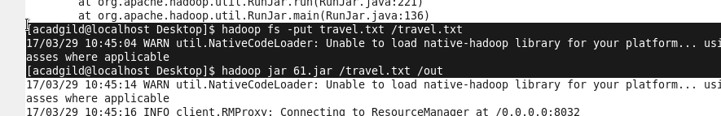

OUTPUT:

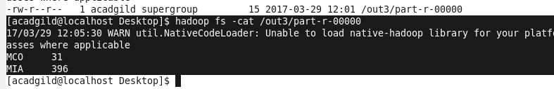

**2) Find out the number of people undertaken the trips from the places MIA and HOU**

**MAPPER:**

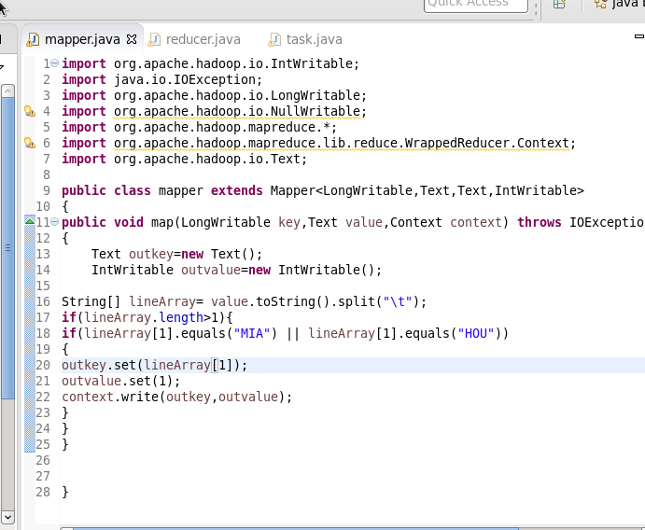



**OUTPUT:**

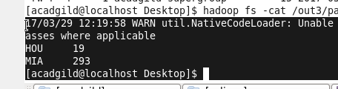

**3)Find out how many people has chosen airline mode of travel for the places LAS and LAX**

**MAPPER:**

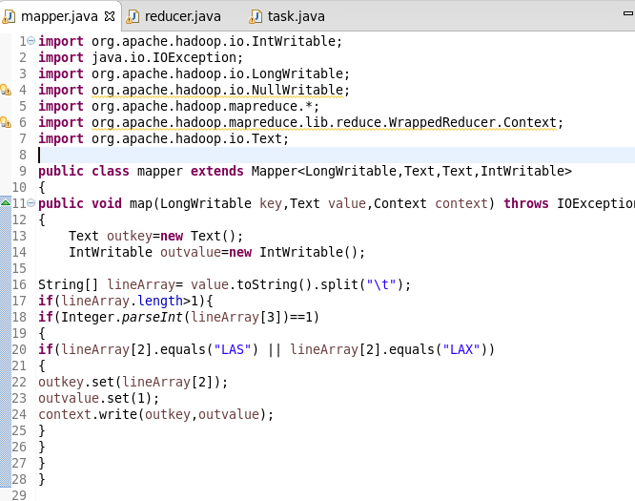



**OUTPUT:**